cutting plotter(Bluetooth version) SDK explanation
- Before starting, please make sure you have completed the preparations.
- If you have not installed Android Studio, please visit the Android official website to download and install。

Quickly integrate SDK
Create a new project in Android studio

Import lib

1.Create a libs folder under the project app file and put the jar package we provide into it. As follows

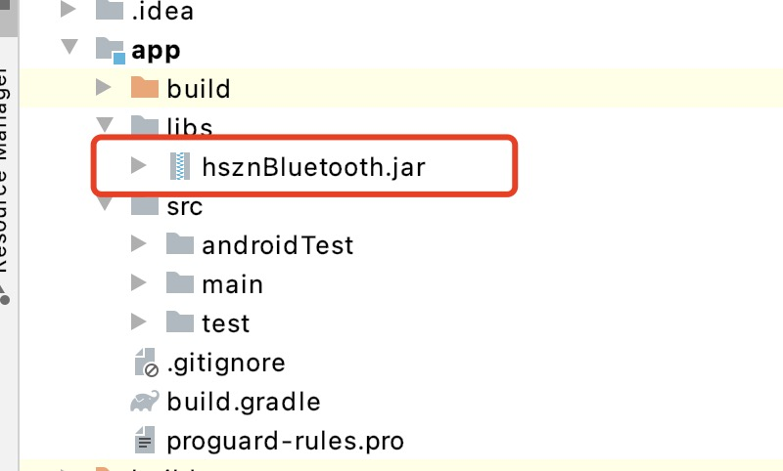

2.Then right-click hsznBluetooth.jar and select add as library, as shown below

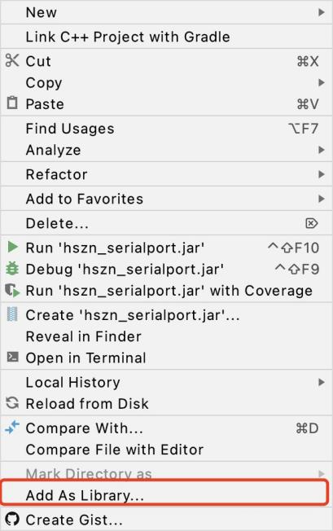

3. In the AndroidManifest.xml file of the app, add the tag code
<uses-permission android:name="android.permission.BLUETOOTH" />
<uses-permission android:name="android.permission.BLUETOOTH_ADMIN" />
<uses-permission android:name="android.permission.ACCESS_FINE_LOCATION" />

特殊说明，如android 6.0以后搜索蓝牙需要定位权限，请手动代码请求权限Special instructions, if searching for Bluetooth after android 6.0 requires positioning permission, please request the permission manually

Initialization
You need to initialize the sdk in the application to ensure that the function can be used normally. code show as below：
public class DMApplication extends Application {
@Override
public void onCreate() {
super.onCreate();
BluetoothSDK.init(getApplicationContext(),"",5000);

}
}
parameter | explanation
Parameter 1 | Fix password
Parameter 2 | Send timeout in millisecond

Use sdk
#Search Bluetooth （Parameter 1, Send timeout in millisecond）
void search(int var1, IBluetoothSearchListener var2);
#Stop search bluetooth
void stopSearch();
#Connect bluetooth
void connect(SearchResult var1, IBluetoothConnectListener var2);
#Connect bluetooth
void connect(String var1, IBluetoothConnectListener var2);
# query machine ID
void queryMachineCode(IBleValueResultCallBack<String> var1);
# Query machine cutting pressure
void queryMachinePressure(IBleValueResultCallBack<Integer> var1);
#Query machine cutting speed
void queryMachineSpeed(IBleValueResultCallBack<Integer> var1);
#Query machine width
void queryMachineWide(IBleValueResultCallBack<Integer> var1);
#query machine scale
void queryMachineGear(IBleValueResultCallBack<Point> var1);
#query machine limit switch
void queryMachineLimit(IBleValueResultCallBack<Boolean> var1);
#query machine mainboard version
void queryMachineVersion(IBleValueResultCallBack<String> var1);
#Query machine cutting status
void queryMachineStatus(IBleValueResultCallBack<Integer> var1);
#Set machine pressure
void setMachinePressure(int var1, IBleDefaultResultCallBack var2);
#Set machine speed
void setMachineSpeed(int var1, IBleDefaultResultCallBack var2);
#Set machine width
void setMachineWide(int var1, IBleDefaultResultCallBack var2);
#Set machine scale
void setMachineGear(Point var1, IBleDefaultResultCallBack var2);
#Set machine limit switch
void setMachineLimit(boolean var1, IBleDefaultResultCallBack var2);
#set automatic feeding switch
void setMachineAutoPager(boolean var1, IBleDefaultResultCallBack var2);
#machine auto-feeding space
void setMachineAutoSpace(int var1, IBleDefaultResultCallBack var2);
#Test cut
void testMachine(IBleDefaultResultCallBack var1);

void cutFile(String var1, String var2, int var3, int var4, int var5, int var6, boolean var7, boolean var8, int var9, boolean var10, IBleCutProgressCallBack var11);
#cutting file （1.content，2.name，3.false）
void cutFile(String var1, String var2, boolean var3, IBleCutProgressCallBack var4);

#Machine version
String machineVersion();
#If connect
boolean isConnected();
#disconnect bluetooth
void disConnected();
#Weather bluetooth turned on?
boolean isOpened();
#Open bluetooth
boolean openBluetooth();
#bind bluetooth address
void setBind(String var1);
#Clear bluetooth bind
void clearBind();
#utomatically connect to bind bluetooth
void startAutoConnect();
#Stop automatic connection
void endAutoConnect();
#Register monitor the Bluetooth connection status
void registerConnectListener(IBluetoothConnector var1);

void unRegisterConnectListener(IBluetoothConnector var1);
#Register monitor the Bluetooth switch status
void registerBluetoothStatusListener(BluetoothStateListener var1);

void unRegisterBluetoothStatusListener(BluetoothStateListener var1);
#Carriage head restoration
void resetPoint(IBleDefaultResultCallBack var1);
#query carriage head coordinate
void queryXYPoint(IBleValueResultCallBack<Point> var1);
#Set carraige head point （var1 scale （x = 1、y=2）、var2长2）
）
void setXYPoint(int var1, int var2, IBleDefaultResultCallBack var3);
#Set the current coordinates to 0.0
void clearXYPoint(IBleDefaultResultCallBack var1);
#Test cut
void testPressure(IBleDefaultResultCallBack var1);
#Recut
void reCut(IBleDefaultResultCallBack var1);
#query USB file list
void queryUsbFileList(IBleValueResultCallBack<List<String>> var1);
#Cut USB file （subscripts start at 1）
void cutUsbFile(int var1, IBleDefaultResultCallBack var2);
#Query USB status
void queryUsbStatus(IBleValueResultCallBack<Integer> var1);
#Stop cutting
void stopCut(IBleDefaultResultCallBack var1);
#continue cutting
void startCut(IBleDefaultResultCallBack var1);

Returned error code Error message comparison table
error code | explanation
0 | The instruction is processed successfully
1 | Write parameter error
2 | Parameter value is incorrect
3 | The machine ID number has been set and cannot be set repeatedly
4 | Commands not supported
5 | The receiving buffer is full, do not continue to send data
6 | The frame sequence number is wrong
7 | The received file length is inconsistent with the file size
8 | The receiving buffer is full, please wait until the buffer is empty and resend this frame (send read status frame query buffer)
9 | The previous file did not end the cutting.
10 | Mode is wrong, server password can only be set in AP mode.
11 | The status is wrong.

